**Assignment 4 :** Writing Backend Scripts and Processing Database data

**1**. Create Data Model (ER Model) and Database design using SQL

**Screenshot:**

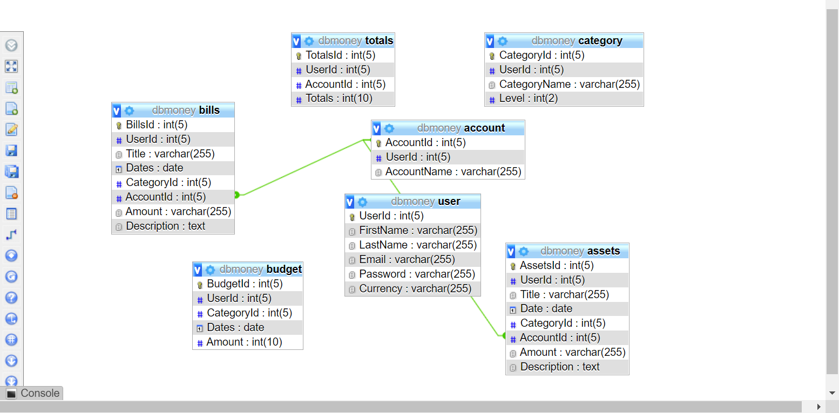

**2**. Connect this database to your already created Data Entry Form.

**Code:**

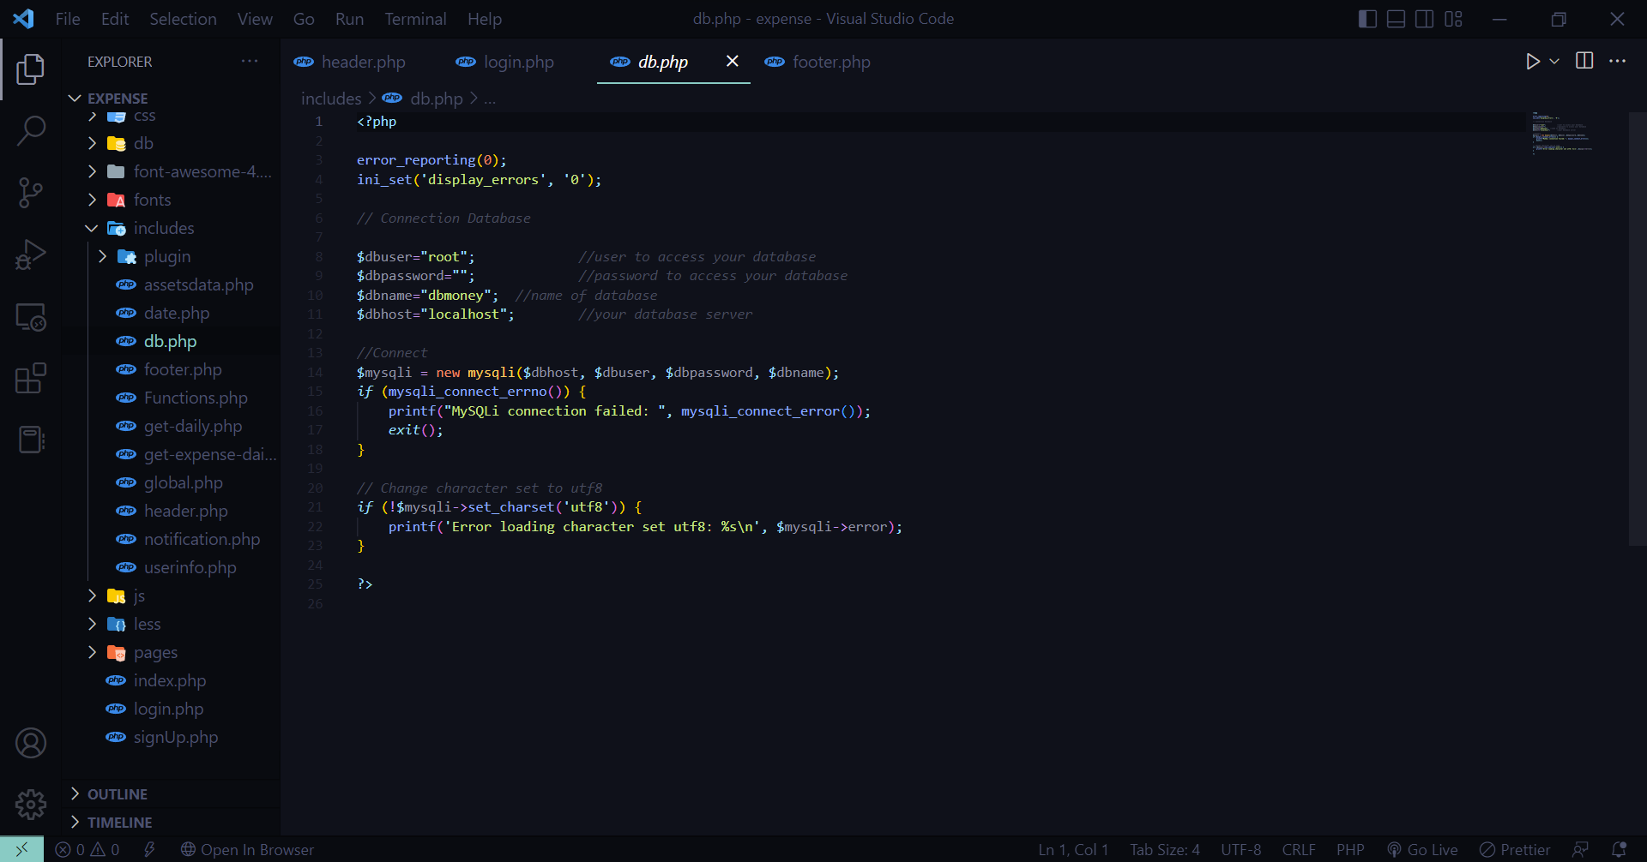

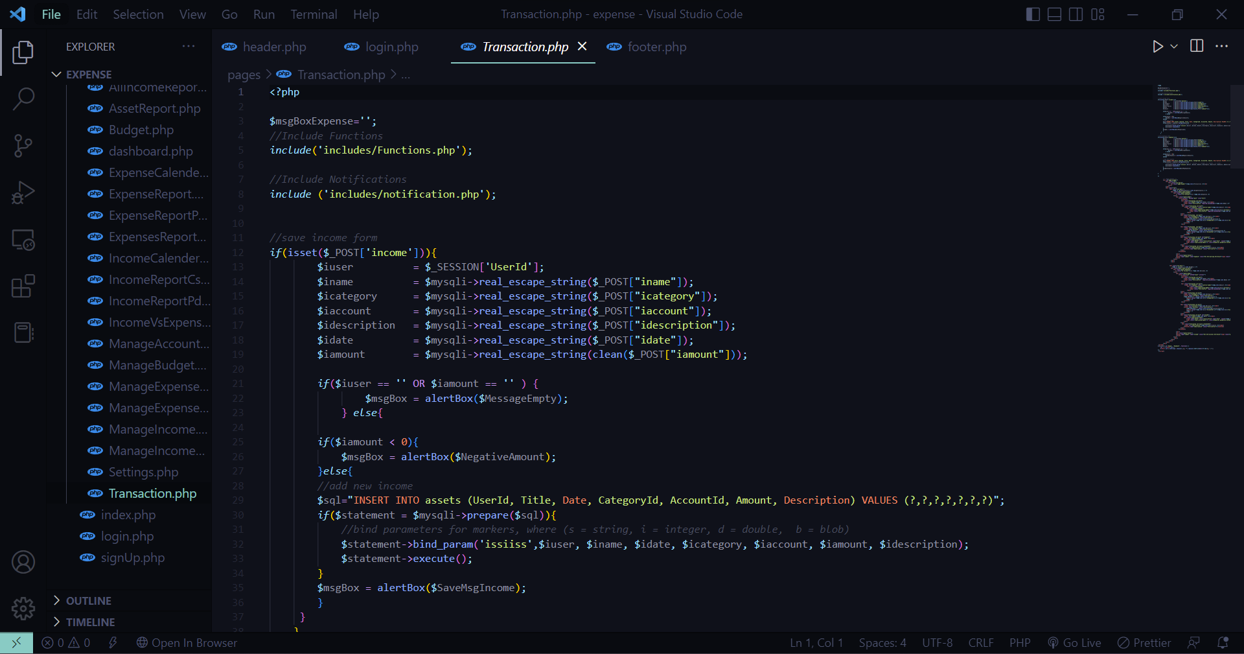

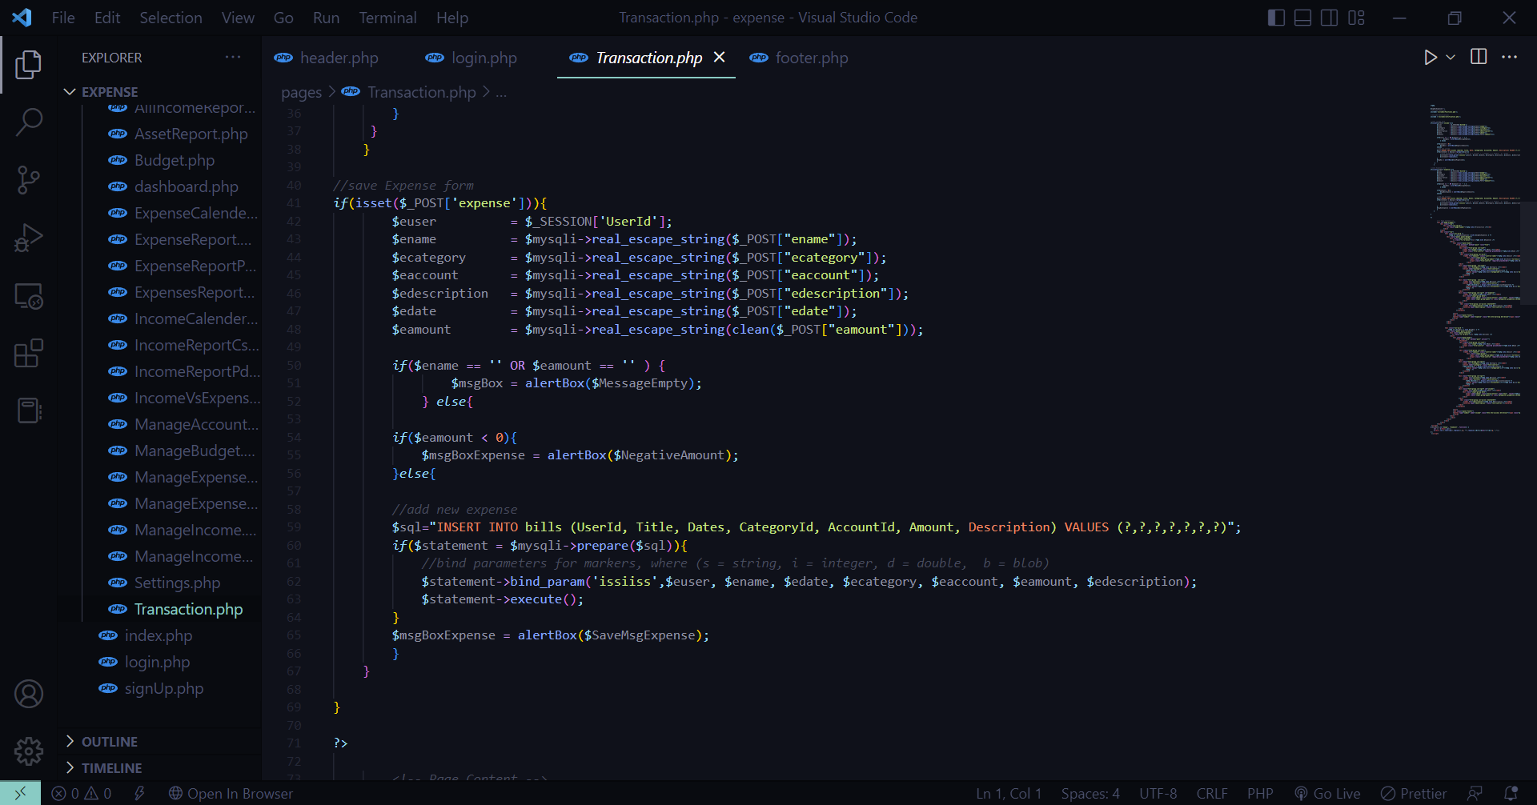

**Screenshot:**

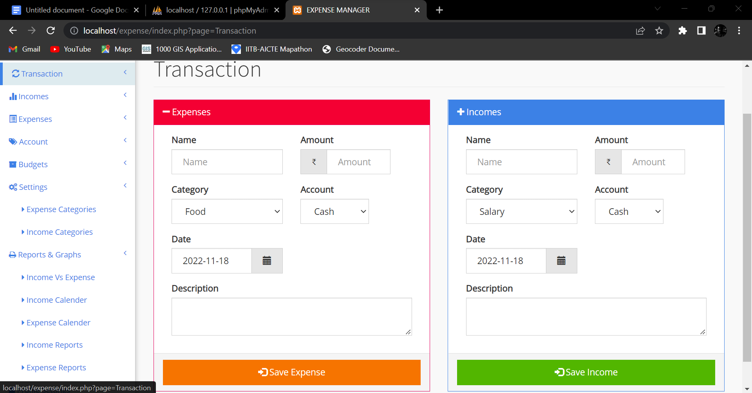

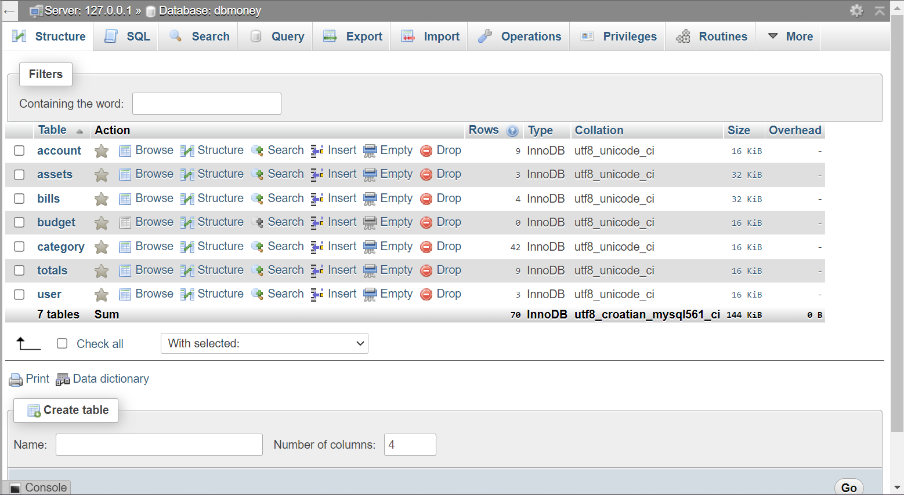

**3**. Write data into the database through Data Entry forms, and Retrieve the same to display on Data Entry Form and Web Records (display in row-column format on webpage). Edit/Update the

Record at form level itself.

**Code:**

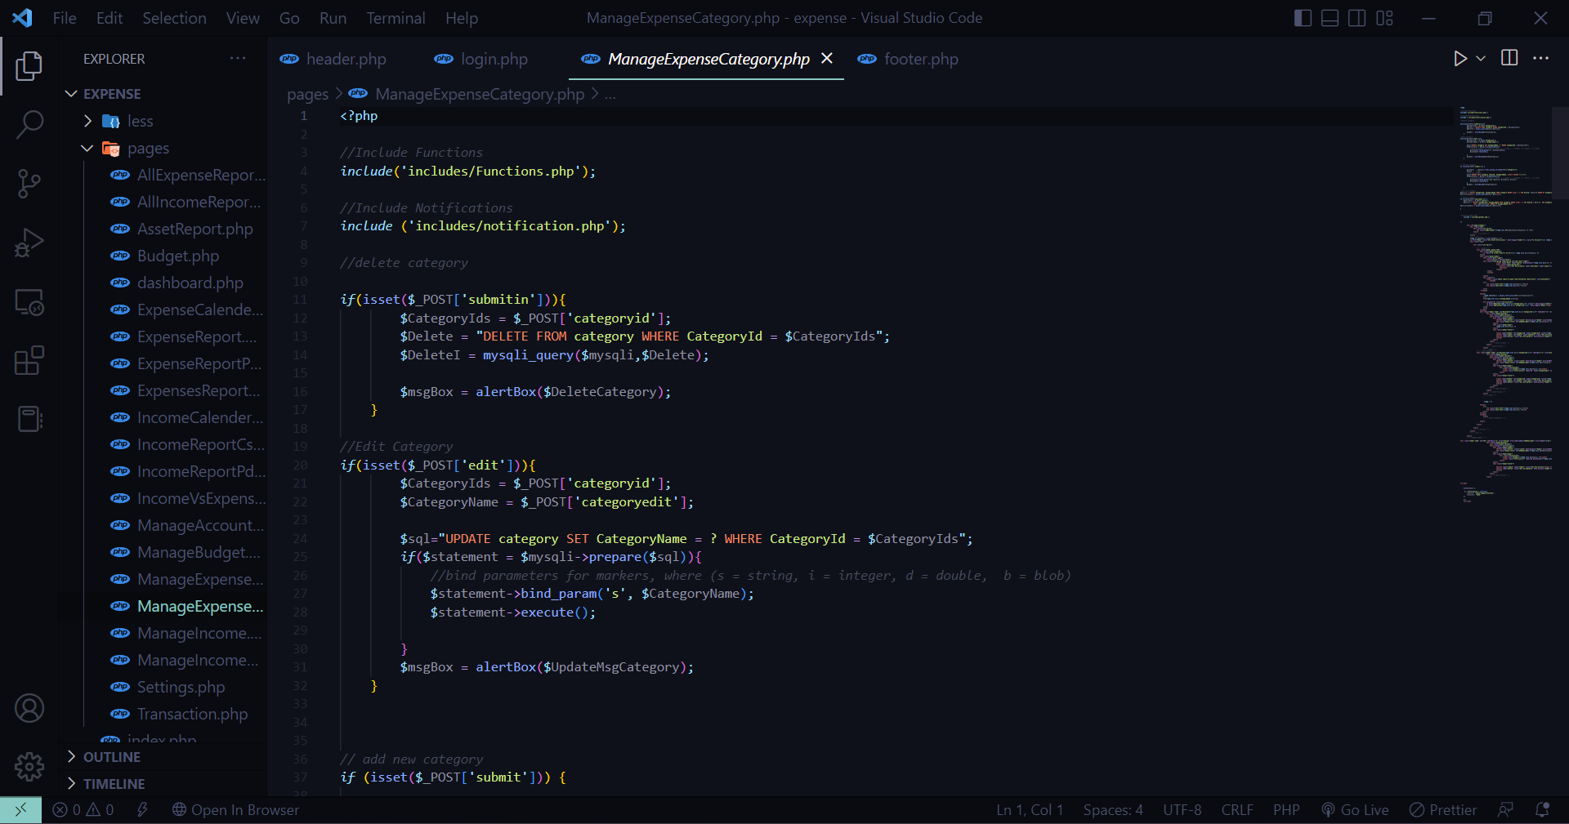

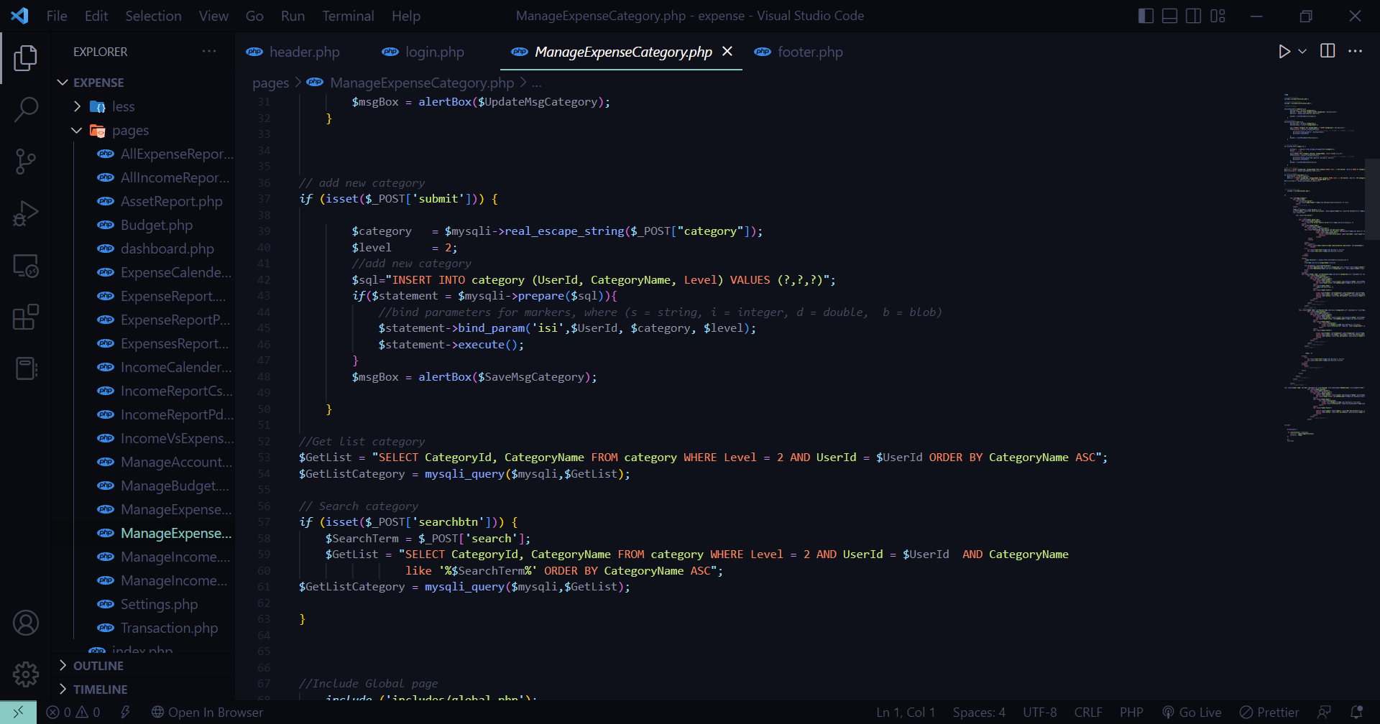

**Screenshot:**

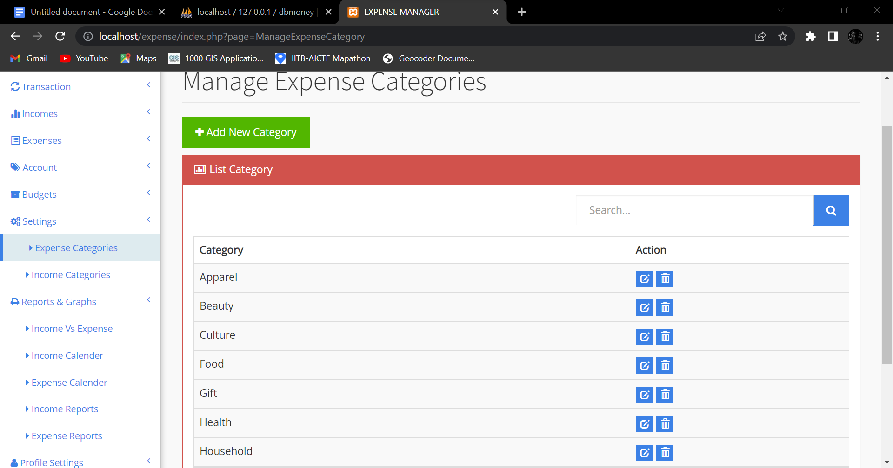

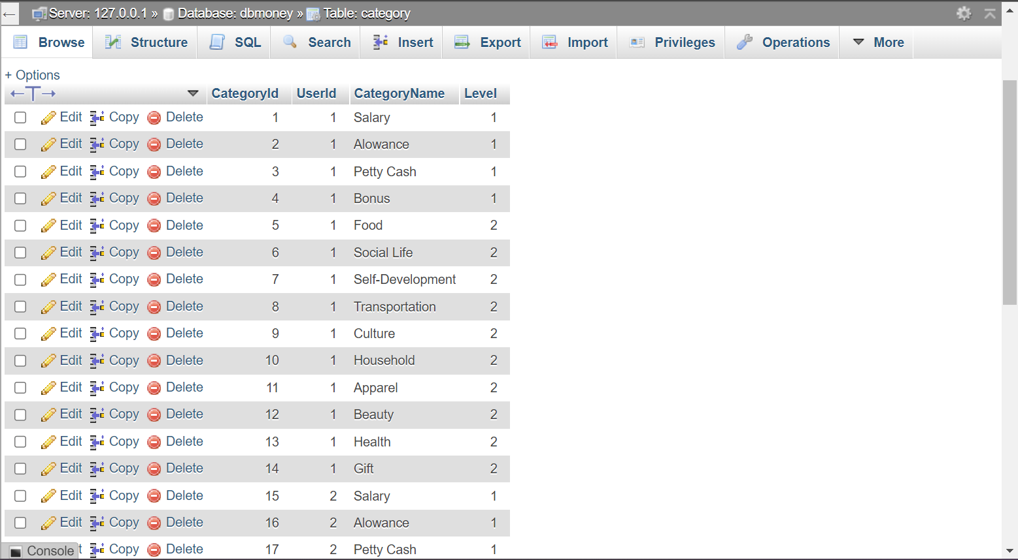

**4**. Include, large files, image, and video data to store and retrieve (upload and download).

**Code:**

**Screenshot:**

**5**. All the data entry forms should have php scripted validations.

**Code:**

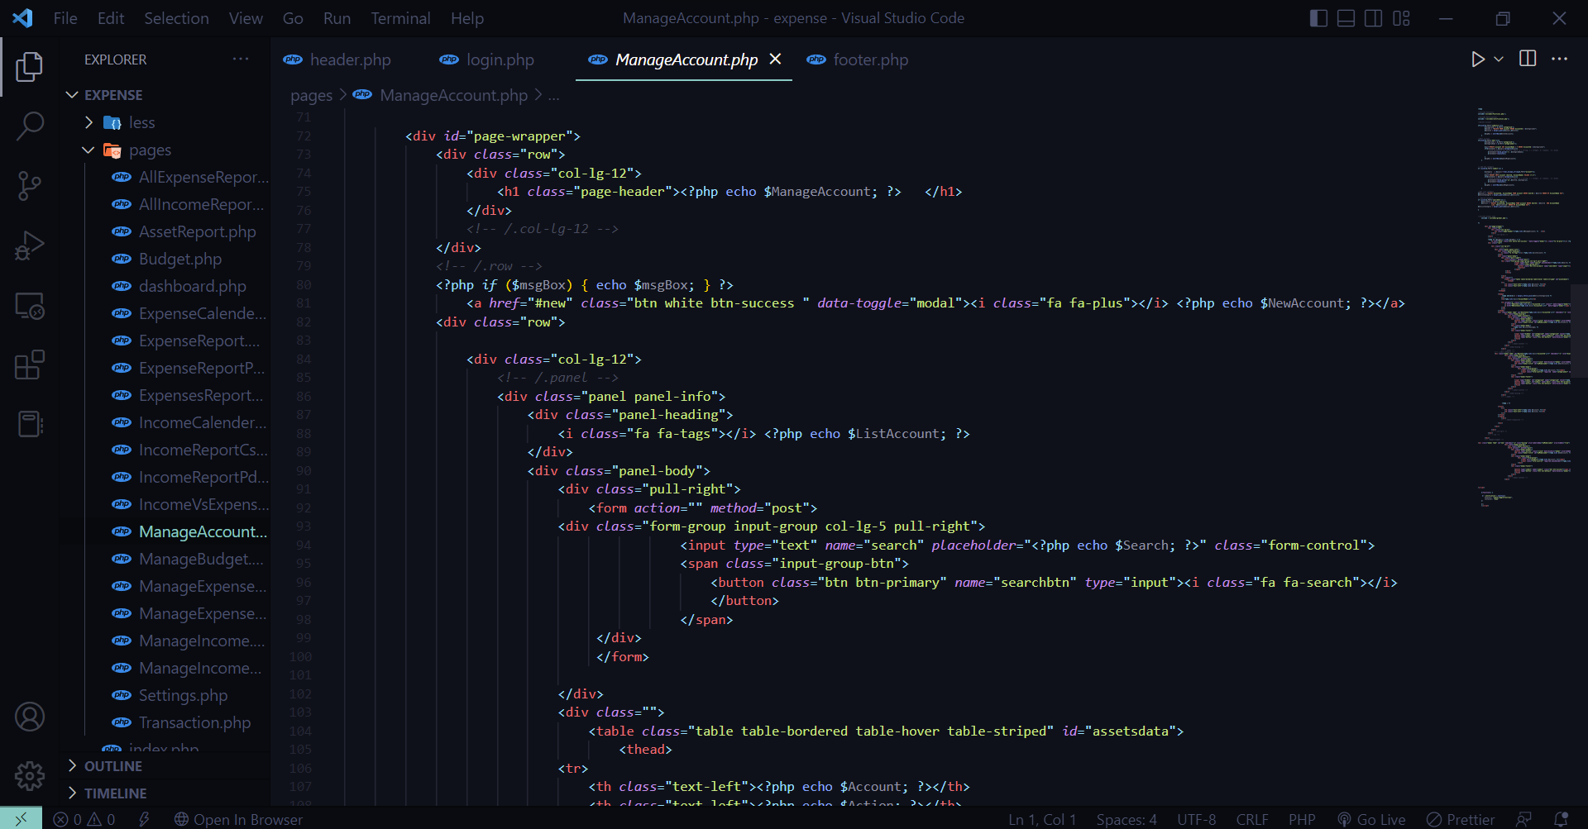

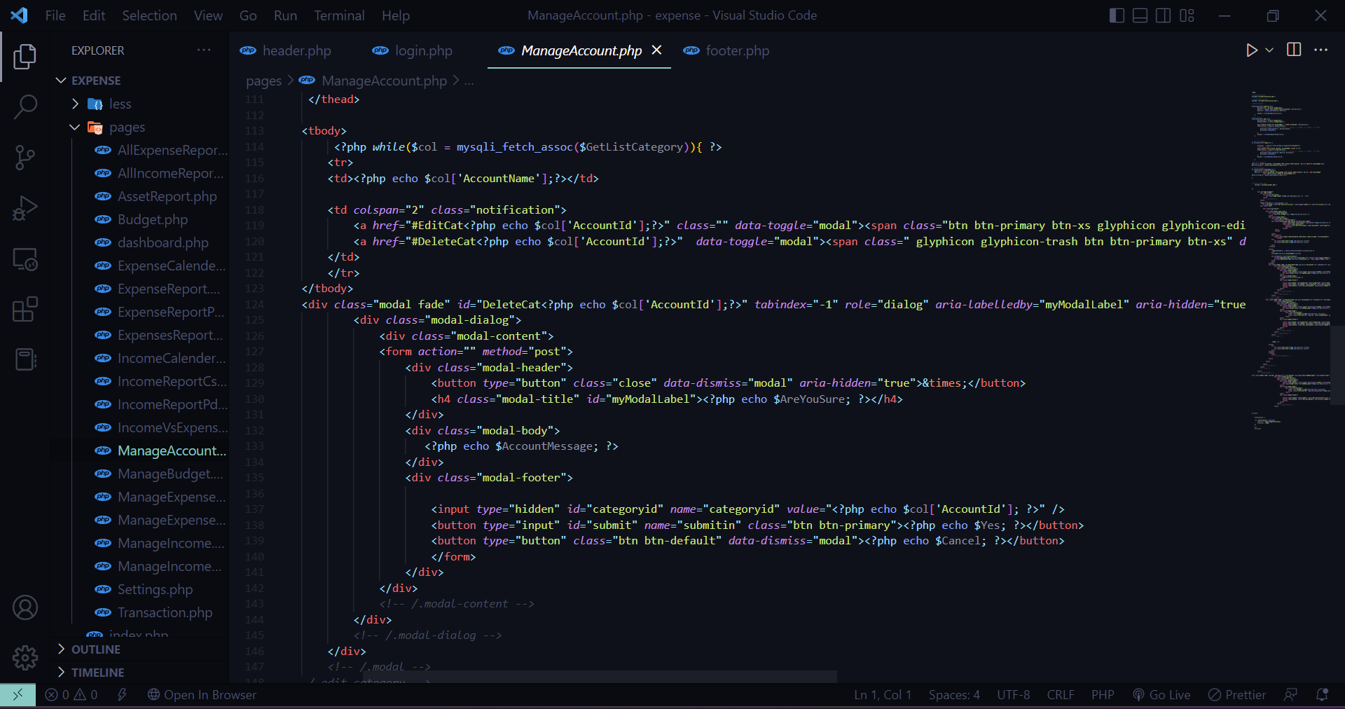

**Screenshot:**

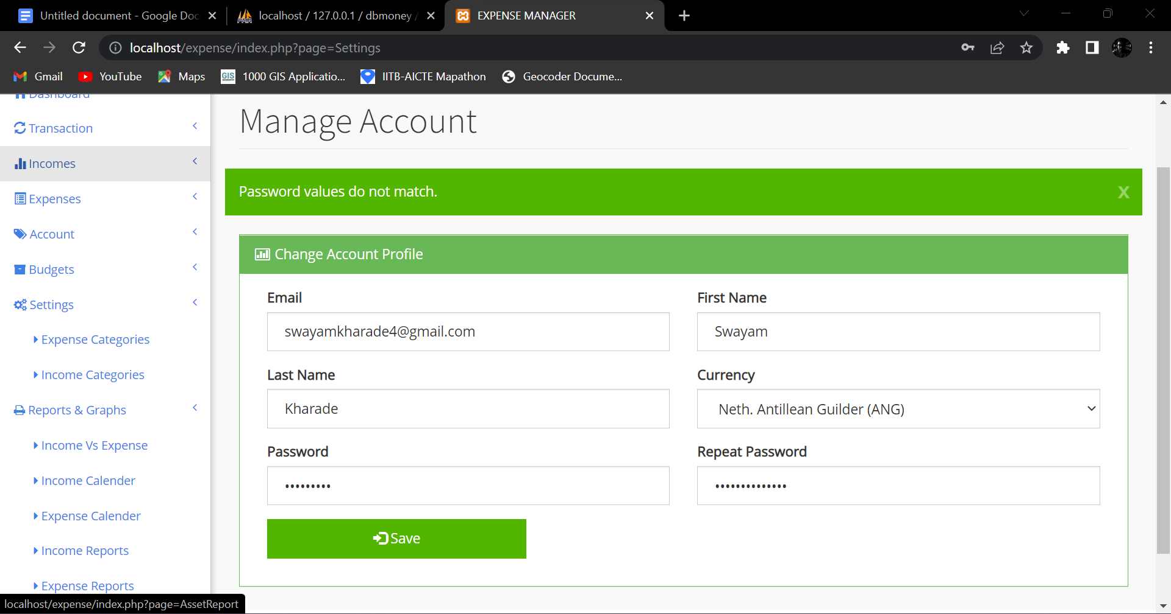

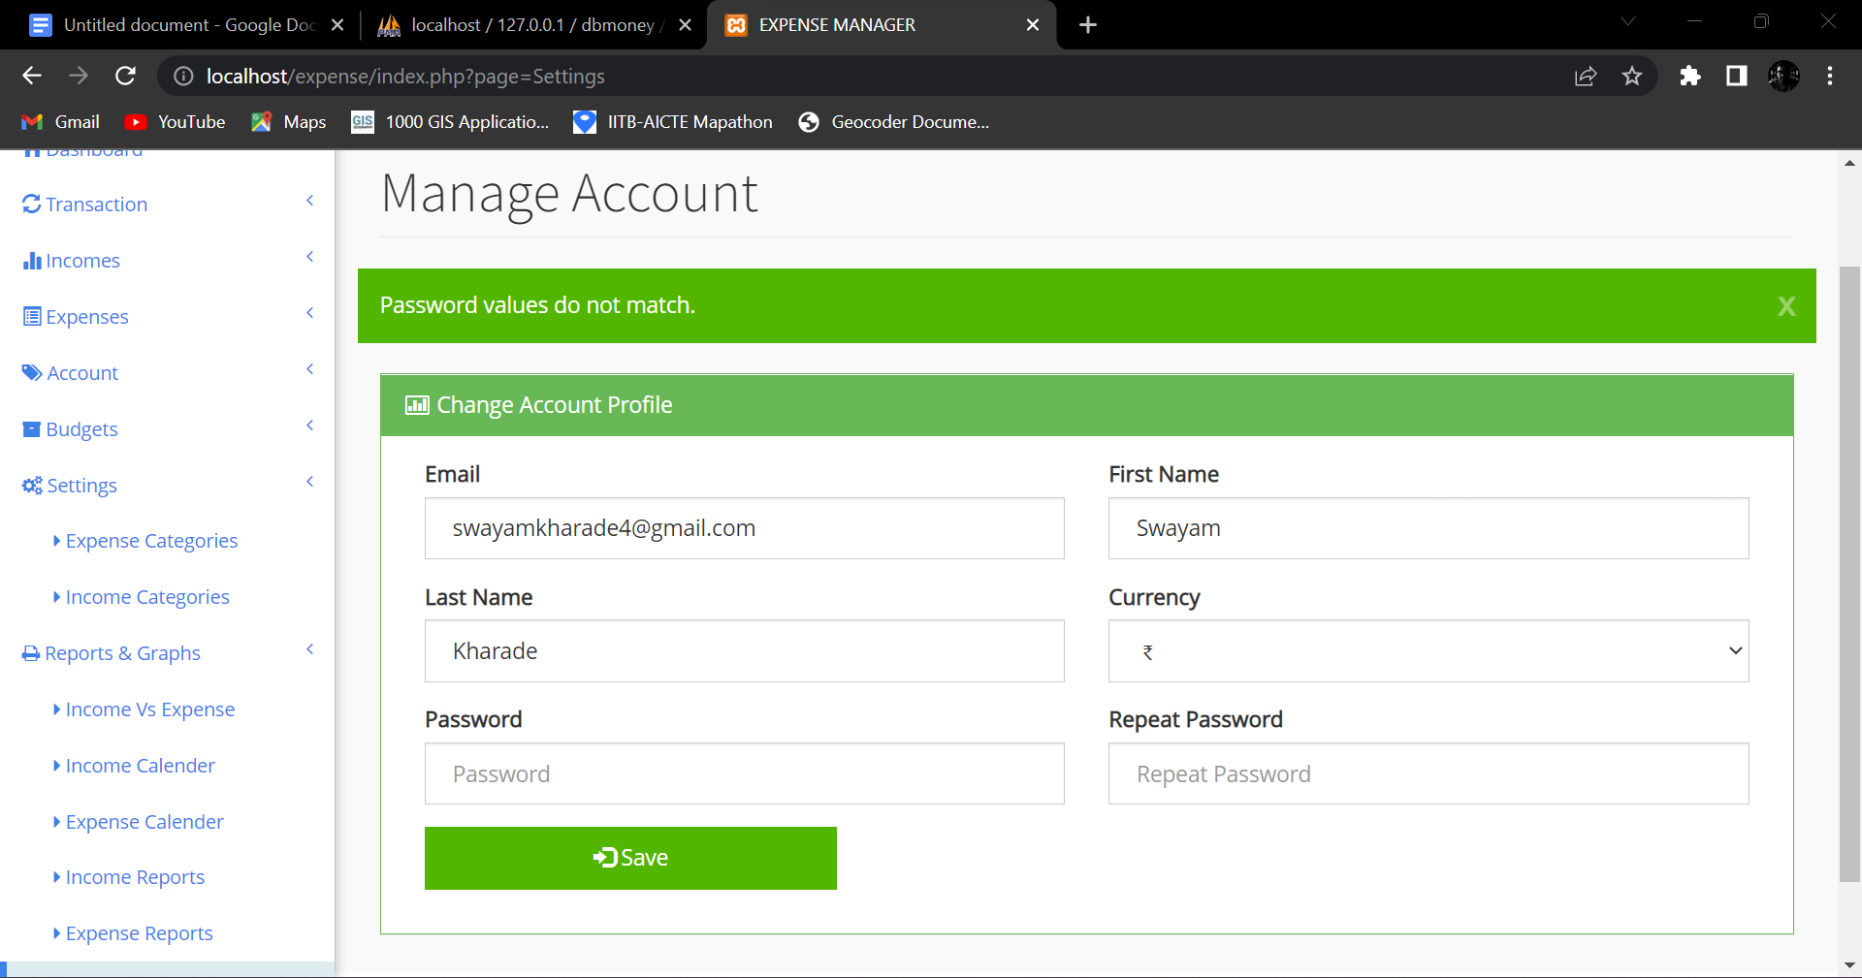

**6**. Write a session script to create an active login session, expiry of the session will store the data temporarily.

**Code:**

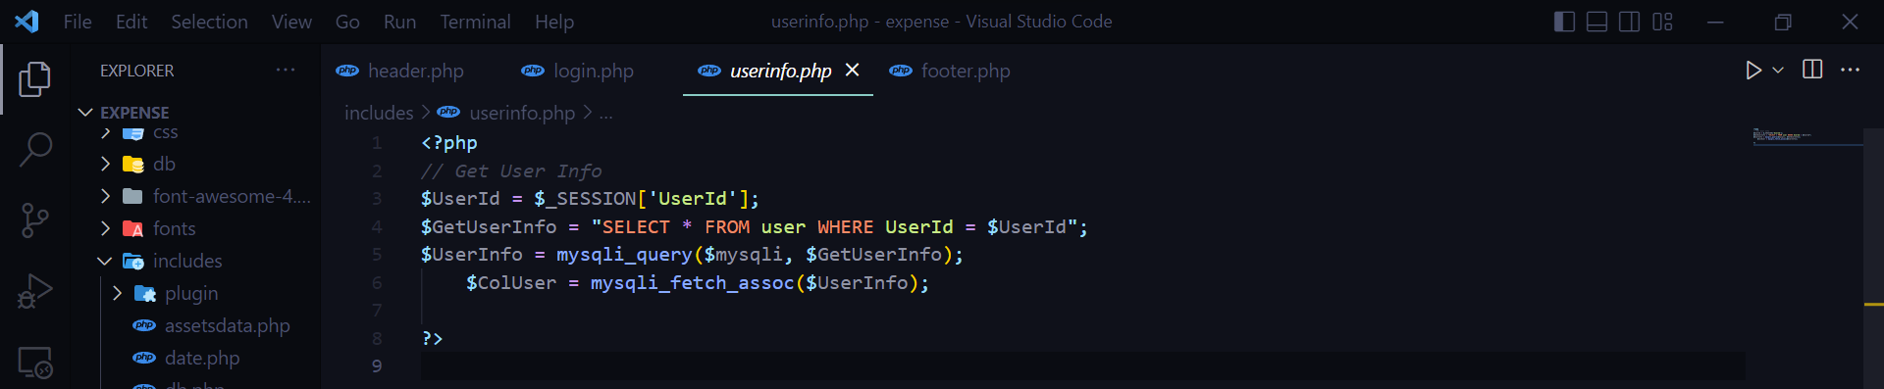

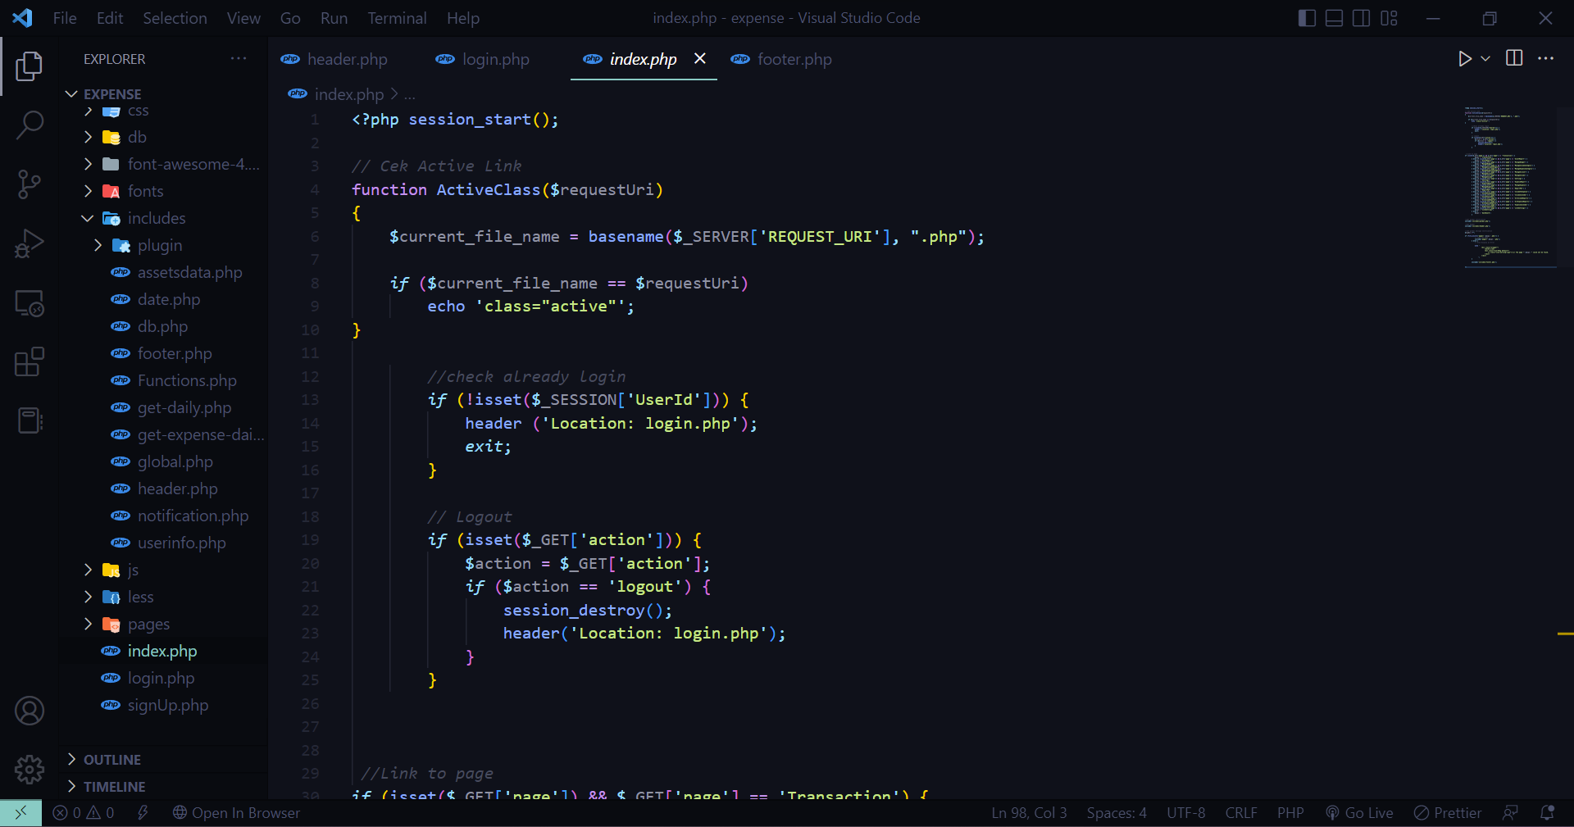

**Screenshot:**

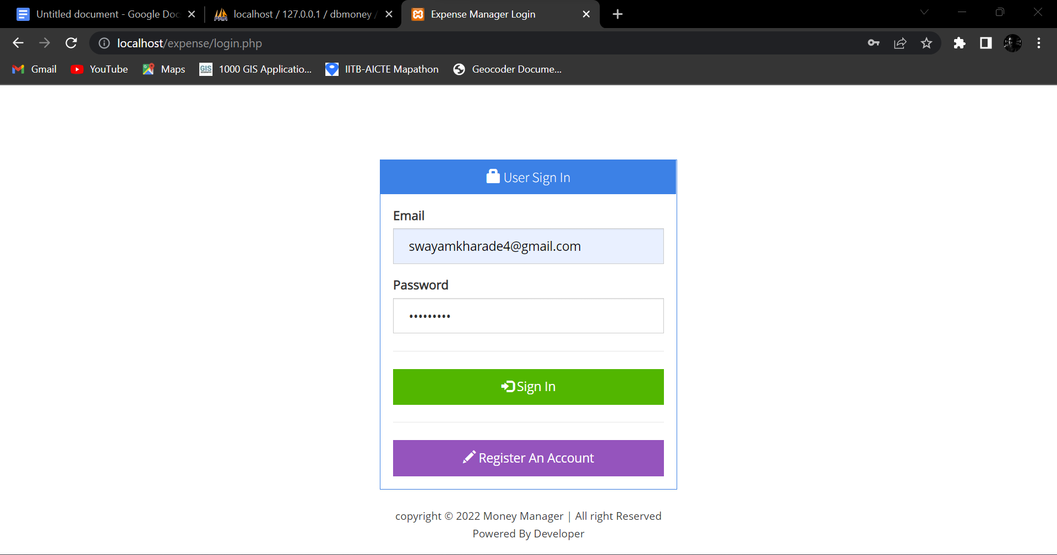

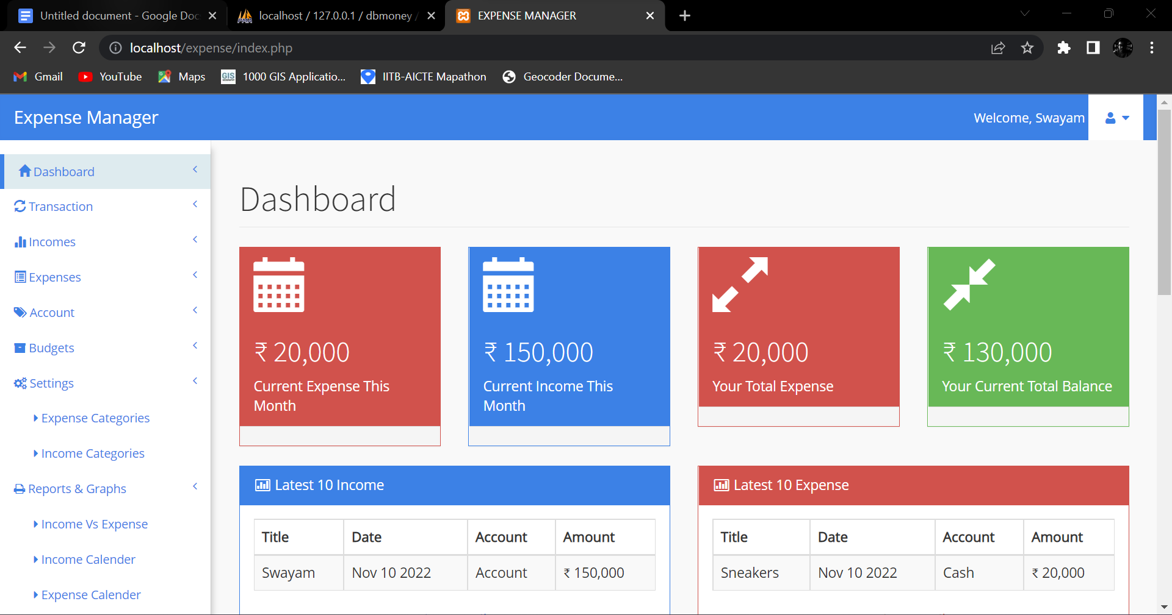

**7**. Write cookies for requesting permission to store user data, and store/use the next time.

**Code:**

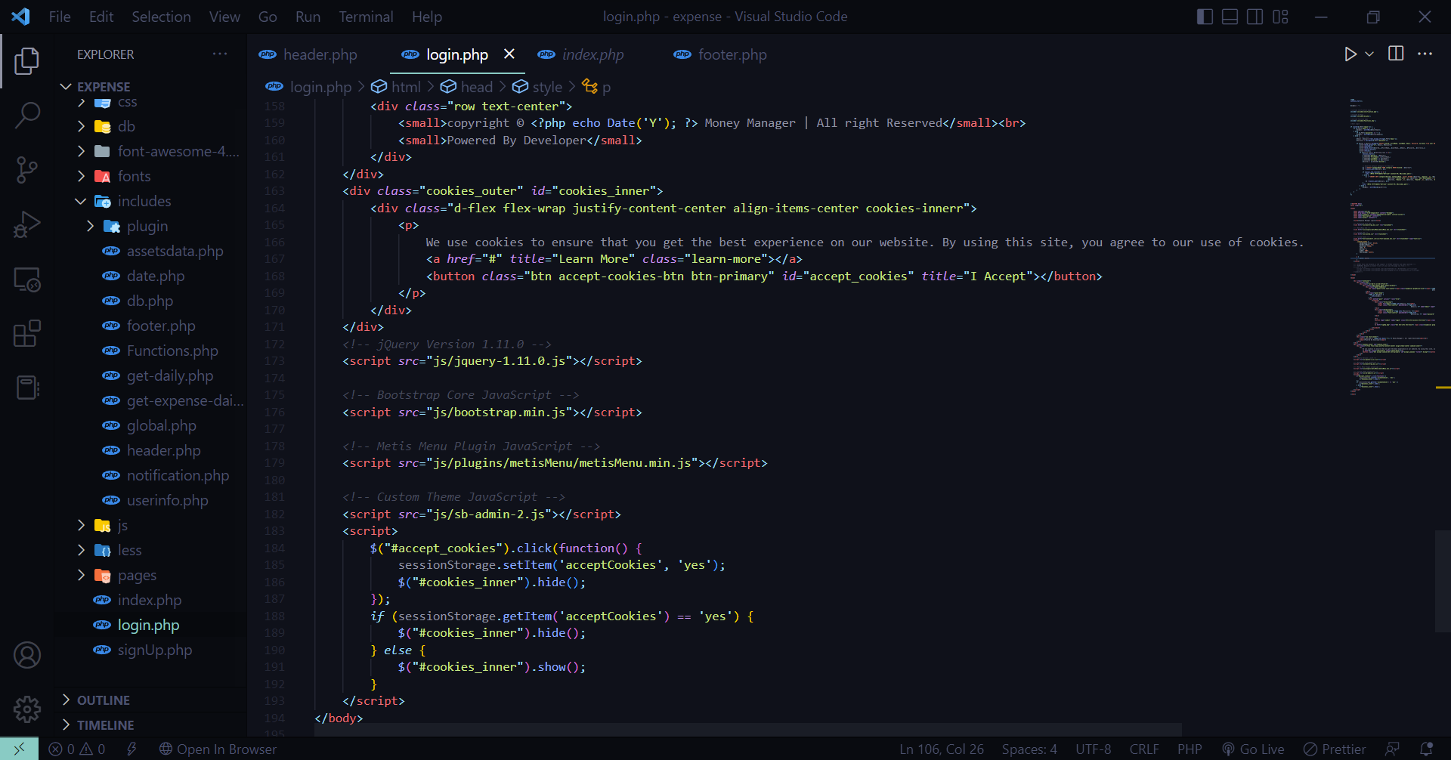

**Screenshot:**

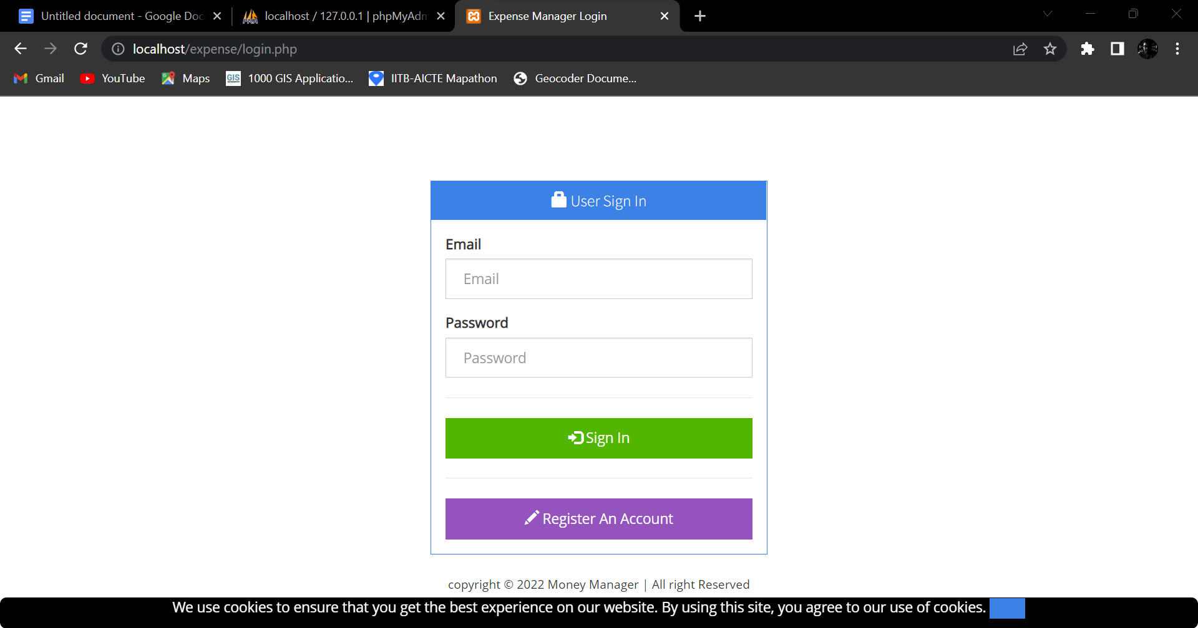

**8**. Incomplete filled data due to session time out or partial save, should be notified to use through phone/email to complete the data entry. Send confirmation of submit status to the user through email and mobile.

**Code:**

**Screenshot:**

**9**. Create a sticky form for data entry so that contents should be saved for the next login.

**Code:**

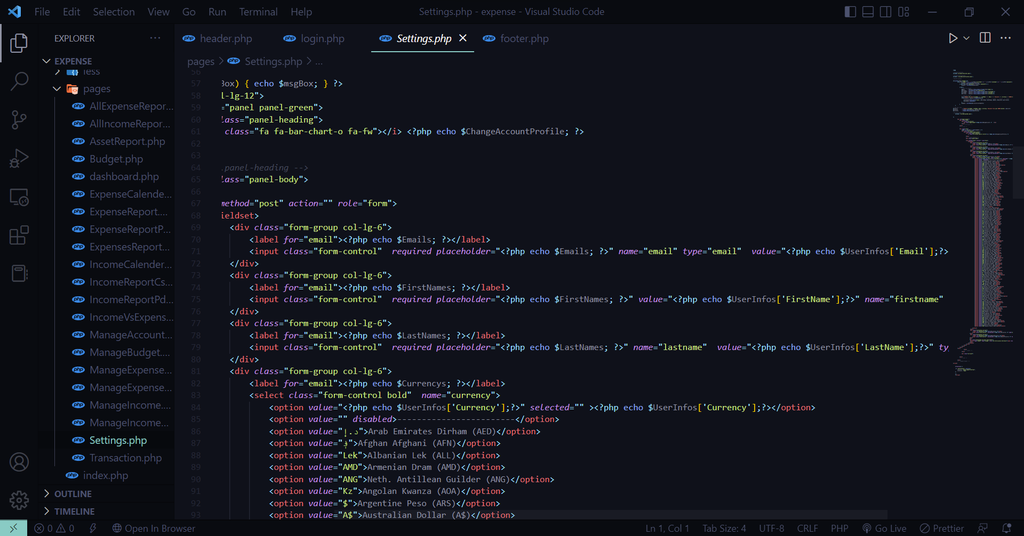

**Screenshot:**

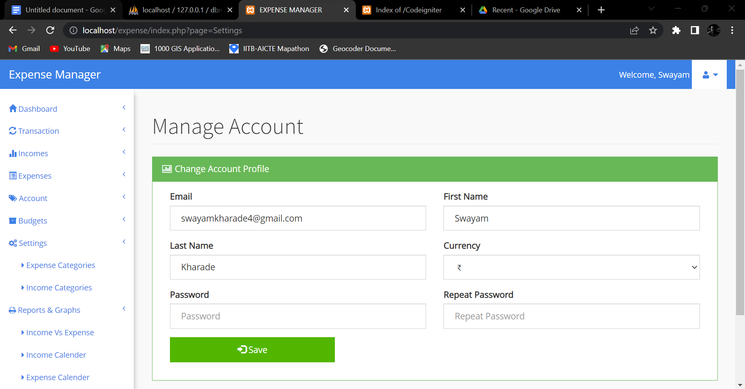

**10**. Create a pdf report (through PhP) of the filled data and send it to the user through email. (Try JasperReports, iReport like reporting and visualization tools)

**Code:**

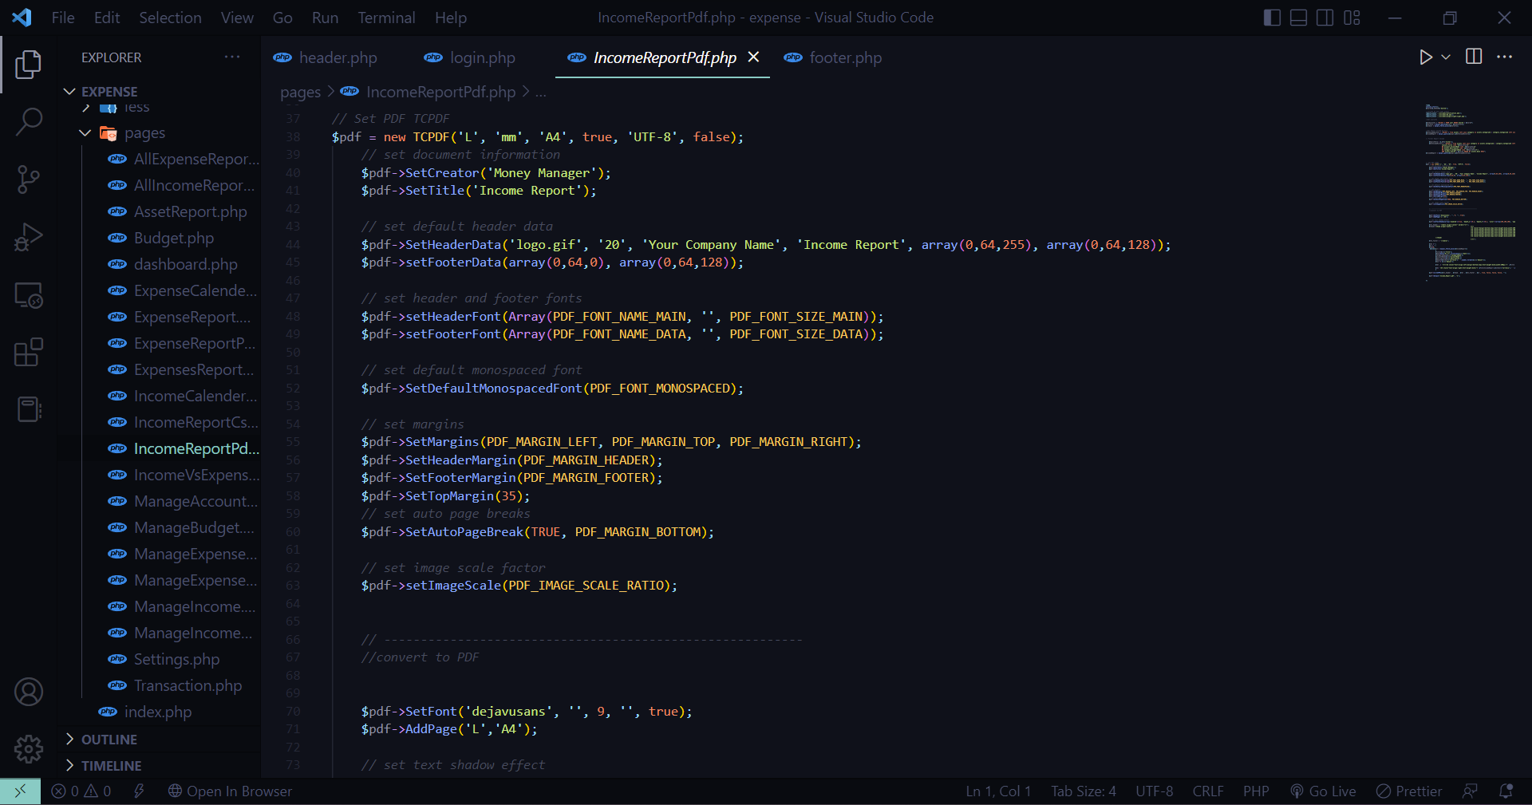

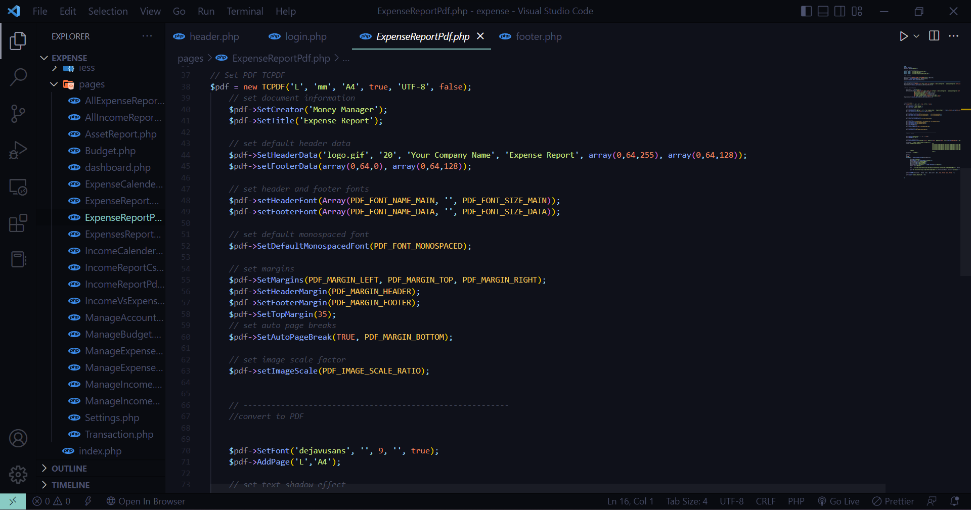

**Screenshot:**

